Ace Pump Inc Software Spec

The Ace Pump software system tracks information about the pumps repaired inside Ace Pump’s shop. This information is consolidated into the parts history reporting system and also used to produce digital receipts and invoicing for customers.

Table of Contents

Purpose 1

Future Goals not Included in the Current Version 2

Part History Reporting 2

Customer Dashboard Screen 3

Reasons Repaired Dashboard Screen 5

Lease Dashboard Screen 7

Well Dashboard Screen 8

Part Dashboard Screen 9

Delivery and Repair Tickets 10

Seneca calls to say the pump in Well 1-5 at the Elberta lease is broken 12

John in the shop is working on a failed pump 13

John finds that the SHELL,STL 2-1/4 IGC in the CAGE, WSV IG 2-1/4 W10TH is broken, but the rest of it is fine 14

Tonya wants to bill a delivery ticket after the shop is done with the repair ticket 14

# Purpose

The final scope will be a functional specification of the software system Netsmith Inc. is producing for Ace Pump Inc. The spec is a living document which will be updated at the beginning of each release cycle to reflect the most current workflow and business decisions about the Ace Pump software system. The spec only describes the delivery and repair ticket system in the original section of the software. I have included workflow diagrams to describe the process, but there are no screenshots.

This spec is the ultimate authority on what the *functionality* of the software. Be sure to review it carefully and contact us if anything is incomplete or inaccurate. Our developers do all of their development work based on the spec, so if it is wrong, the software will end up performing wrong. To illustrate functionality, we have included graphical mockups of the pages we are designing, however the graphic elements are by no means complete. The text, layout, and design will be updated as we develop the system.

# Future Goals not Included in the Current Version

The current software version will *not* include these features.

* Integration of the delivery ticket system with the QuickBooks invoicing system at Ace Pump
* Automatically e-mailing delivery ticket PDF’s to the customer when Tonya clicks “Print”
* Repair ticket part validation and update against the pump template of the failed pump
* Database auditing and restructure
* Assigning a tax rate to each customer which will be used by default on delivery tickets for that customer

# Part History Reporting

All the individual part repairs the shop techs enter into the system gets consolidated into the part history reporting system. The system uses five separate dashboards to display a good overview of the types of failures, the causes, and the cost of repairing them. The dashboards are cross-linked and also link directly into the individual delivery and repair tickets where relevant.

All the dashboards update automatically, meaning, as the filters and selections are changed, the data widgets all update. There is also a date range feature on all the dashboards.

There are two types of widgets in the system, the chart widget and the change widget. The chart widget shows a pie, bar, or line chart summarizing the information. The pieces of the chart (e.g. pieces of the pie) can be clicked on to see the related dashboard. For example, you can click on a part in the “Top Failing Parts” pie chart to see the parts dashboard for that part.

The change widget shows a comparison between the current status and the way it was at the same time period last year. There is an arrow pointing up if the value has increased, down if the value has decreased, or blank if there was no change. The widget also uses the color to indicate if the change is good or bad for the business. This allows us to have some widgets (like Average Daily Repair Cost) where an increase is bad and some (like Average Runtime) where an increase is good. The exact value of the change is indicated right below the current value.

## Customer Dashboard Screen

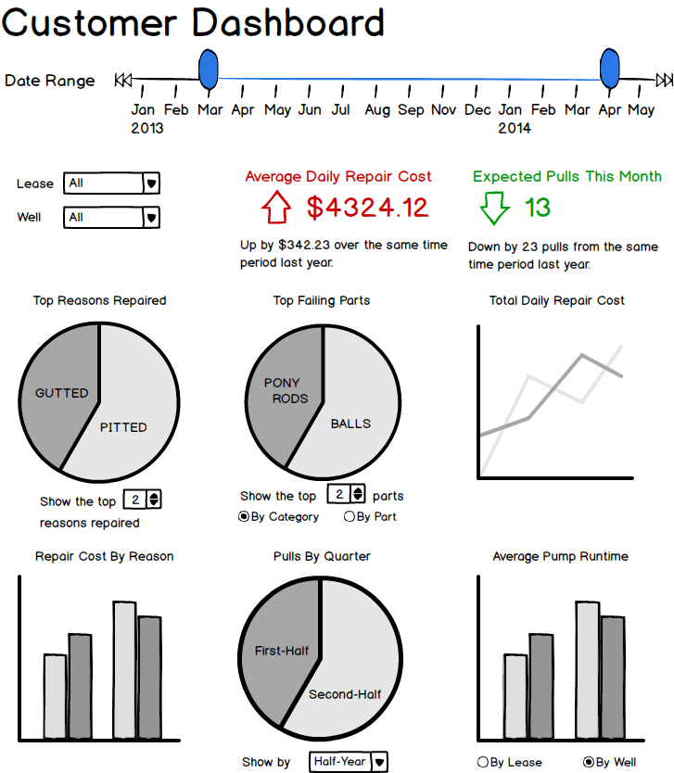

The main customer portal for analyzing their historical pump failure data. When a customer logs in, they see these reports for only their data. Ace Pump employees can access this same data using the “Impersonate” feature. The data can be further filtered by lease, well, or date range.

|  |  |
| --- | --- |
| Average Daily Repair Cost | The average amount the customer paid to repair pumps divided by the number of days in the selected period. |
| Expected Pulls this Month | The average number of pulls made over the past three months at all the specified leases and/or wells. This widget does not change when the date range is adjusted. |
| Top Reasons Repaired | A pie chart showing the top reasons Ace Pump shop techs are repairing pumps. The number of reasons to show is adjustable with the spinner right below the chart.  This chart gets its data from the reason the shop tech listed on every repair ticket they did for the customer during the time period. |
| Top Failing Parts | A pie chart showing which pump parts are failing the most often. This chart can be organized by category (the default) or by specific part. The customer can also choose how many parts to show in the chart. |
| Total Daily Repair Cost | A line chart showing the fluctuations in daily repair cost over the course of the specified time. Each day shows up on the line chart as a point. |
| Repair Cost by Reason | This bar chart shows one bar for each reason Ace Pump repaired one of the customers pump. The bar shows the *total* amount the customer spent repairing parts for that reason, not an average.  Service charges are not considered when calculating the total repair cost. |
| Pulls by Quarter | Helps the customer identify when the most pulls are happening. This chart can show pulls either by quarter or by month. |
| Average Pump Runtime | One bar for each well or lease (selectable by the customer). The bar shows the average length of time a pump in the ground at that location was able to run before being pulled.  The average runtime is the length of time that passed from when the pump was installed in the well until it was pulled back out. The reason for the pull is not considered when calculating the runtime. |

## Reasons Repaired Dashboard Screen

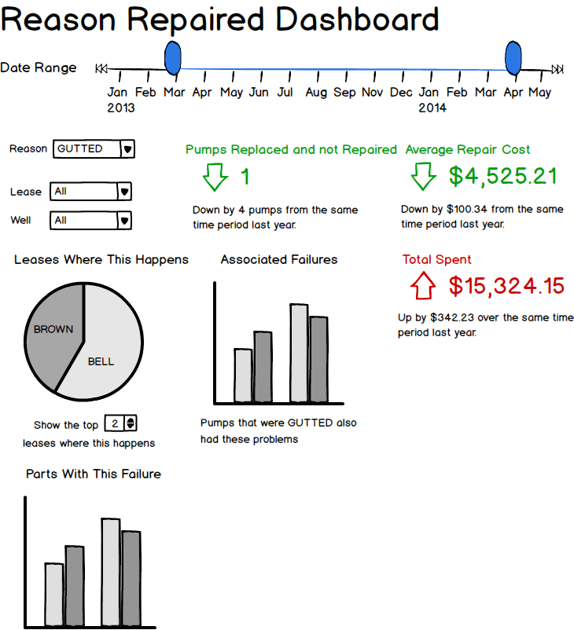

A focused view on the reasons pumps are breaking. The data for this dashboard comes from every repair ticket Ace Pump does for the customer. The more tickets available, the more useful the data.

Also has a drop down filter to choose which reason repaired to view data for.

|  |  |
| --- | --- |
| Pumps Replaced and not Repaired | The number of pumps with this failure where the repair cost was more than the cost of a brand new pump. |
| Total Spent | The total amount the customer has spent fixing pumps with this problem. This counts only the amount the customer spent fixing this problem itself and does not consider the cost of fixing other broken parts of the pump or service charges. |
| Average Repair Cost | The average amount the customer has spent fixing pumps with this problem. This counts only the amount the customer spent fixing this problem itself and does not consider the cost of fixing other broken parts of the pump or service charges. |
| Leases Where this Happens | This pie chart shows a breakdown of the leases where this happens most often. This can help the customer identify reasons that may be contributing to failures like a poorly trained foreman or bad terrain at a particular lease.  The customer can click on any lease to jump to the lease dashboard for that lease. |
| Associated Failures | This bar chart shows one bar for every other failure that showed up in a pump with this problem. The height of the bar is determined by the number of times the failure showed up. |
| Parts With this Failure | This bar chart shows one bar for each part where this failure happened. The height of the bar is determined by the number of times that part failed with this reason. |

## Lease Dashboard Screen

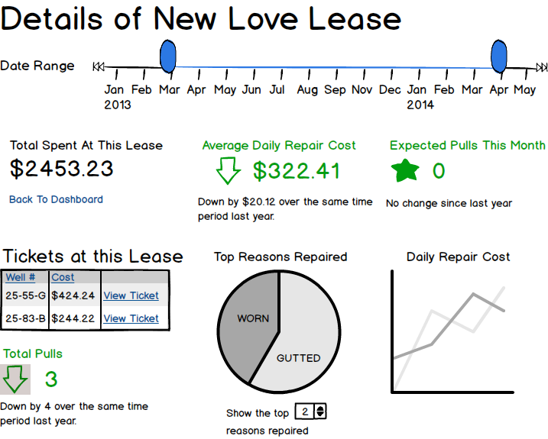

A focused view on one lease. Summarizes data for all the wells at that lease. The name of the lease is displayed in the title bar.

|  |  |
| --- | --- |
| Total Spent at This Lease | The total amount the customer has spent fixing pumps on the chosen lease within the time range specified. |
| Average Daily Repair Cost | The average amount the customer paid to repair pumps each day at this lease within the chosen date range. |
| Expected Pulls this Month | The average number of pulls made over the past three months at all the specified leases and/or wells. This widget does not change when the date range is adjusted. |
| Tickets at this Lease | A grid listing all tickets the customer opened at the specified lease. The customer can click on a ticket to jump to the screen for the chosen delivery ticket. |
| Total Pulls | The number of pulls at this lease over the selected period of time. Unlike the “Expected Pulls this Month” widget above, this widget covers the date range the customer selects. It also provides a *total* number of pulls instead of an *average* number of pulls. |
| Top Reasons Repaired | A pie chart showing the top reasons Ace Pump shop techs are repairing pumps at the chosen lease. The number of reasons to show is adjustable with the spinner right below the chart. |
| Daily Repair Cost | A line chart showing the fluctuations in daily repair cost over the course of the specified time at the chosen lease. Each day shows up on the line chart as a point. |

## Well Dashboard Screen

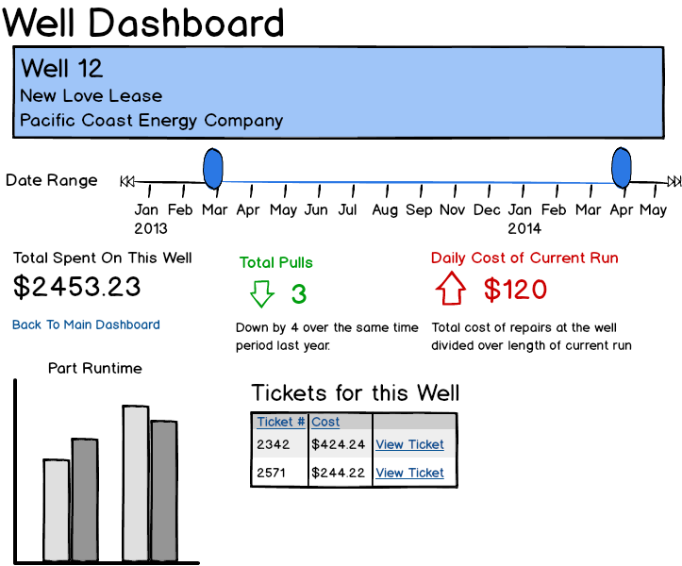

A focused view on a specific well. Summarizes data for all the pumps which have been in that well and provides a snapshot of the current run in that well. Well information is listed at the top of the page.

|  |  |
| --- | --- |
| Total Pulls | The total number of times a pump was pulled out of this well during the specified time period. |
| Total Spent on this Well | The total amount spent on repairing pumps at this well across the time period. |
| Daily Cost of Current Run | The total amount spent on the last pump repair divided out over the length of time since the repair happened. Compared with the daily cost of the previous run. |
| Part Runtime | One bar for each part in the pump currently in the well. The height of the bar indicates how long that part has been running without fail. The bars in this chart cannot be clicked. |
| Tickets for this Well | A list of all the tickets at this well |

## Part Dashboard Screen

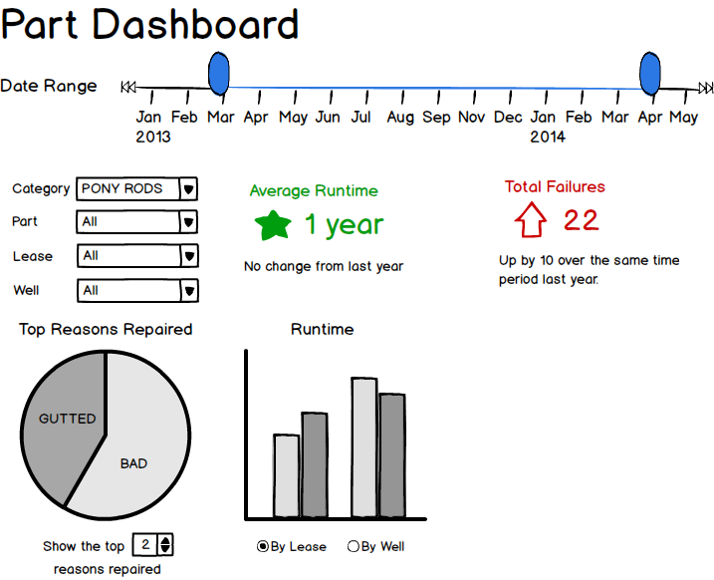

A focused view of a specific part. Summarizes data for all pumps the customer owns which have that part, not just one particular part. Has a drop down to choose part category and part.

|  |  |
| --- | --- |
| Average Runtime | Considers all the pumps the customer currently has with this part inside and takes the average amount of time the part has functioned.  Part runtime is counted for all the time the part is in the ground without needing repair. If the pump is pulled because another part failed, the runtime does not restart. However, the runtime also does not increase until the pump is reinstalled. |
| Total Failures | The total number of times this part has failed in any pump the customer owns. |
| Runtime | Shows one bar for each well (or lease) where the customer has a pump with this part in it. The height of the bar is the length of time that part has been running without fail.  In lease mode, the customer can click on a lease to jump to the lease dashboard for that lease. In well mode, click to jump to the well dashboard for that well. |
| Top Reasons Repaired | A pie chart showing the top reasons Ace Pump shop techs have repaired this part. The number of reasons to show is adjustable with the spinner right below the chart. |

# Delivery and Repair Tickets

Ace Pump tracks all of their work using delivery and repair tickets. The same ticket number is used for the delivery and repair ticket.

* A *delivery ticket* is similar to an invoice. It describes only the repair work and/or part purchases which Ace Pump delivered to the client. Ace Pump also uses delivery tickets for part purchases when they do not do the repair work.
* A *repair ticket* tracks everything the shop did to the pump. The repair ticket includes a line for every part the failed pump has with information about what the shop techs decided to do with that part.

The full delivery and repair ticket workflow is attached at the end of the spec. Let’s explore some sample scenarios from the major sections of the workflow.

Mr. Jones comes to Ace Pump to purchase parts for a broken pump  


This is the simplest way to use a delivery ticket. Tonya selects Mr. Jones’ name from the customer list. She does not need to specify a lease, well, dispatched pump or failed pump. Tonya can add line items directly to the delivery ticket by selecting the part number and quantity of items to be sold. When Tonya adds a new line item, the default pricing information for that part is displayed. Tonya can edit the pricing for that line item *without affecting the default pricing for that part*.

The sales tax rate defaults to 7.5%, but Mr. Jones is from a county where the sales tax is 8%. Tonya can change this amount and sees an update of the pricing before printing.

After confirming everything with Mr. Jones, Tonya can prints a paper copy of the ticket for Mr. Jones to take with him, and/or makes him PDF which she e-mails him.

## Seneca calls to say the pump in Well 1-5 at the Elberta lease is broken



Tonya gets the call and sends out some techs to replace the pump. She immediately opens a delivery ticket for the job and adds Seneca as the customer. She chooses Elberta from the lease drop down and 1-5 from the Well drop down. If the system knows what pump is inside Well 1-5, it automatically gets added to the Pump Failed field of the delivery ticket. If not, Tonya just starts typing the pump number and can add it. She also adds the pump number of the pump the Ace tech’s delivered to Seneca, and saves her work.

Tonya can add as much additional information as she wants to the ticket at this point, or she can wait until she is ready to complete the ticket. She does not even need to add a failed or delivered pump immediately if she does not want. NOTE: The repair ticket *cannot be started* until the failed pump has been set in the delivery ticket.

## John in the shop is working on a failed pump



When the John first opens the repair ticket, he will see a line for every part the pump is supposed to have. If he notices the pump he’s looking at does not match the pump the ticket describes, he can update the pump template and see the ticket regenerate the repair lines. If John needs to add new lines to the repair ticket to represent brand new parts, he can. Those lines will not have a record of an “original” part or quantity because there was no original part.

John needs to enter a status for every part in the pump, even if it’s N/A to indicate he did not inspect that part. If he chooses to replace the part, the system will automatically fill in the number and quantity fields for him. If he chooses to convert it, he’ll need to supply that information.

When John clicks “Save and Close”, the system verifies that John has marked every item on the ticket. If he has, the ticket is closed and John is done. If not, the system tells John and does not close the ticket.

## John finds that the SHELL,STL 2-1/4 IGC in the CAGE, WSV IG 2-1/4 W10TH is broken, but the rest of it is fine

When John is fixing the pump, he may find the cage is mostly fine but it has a broken shell. By default, assemblies (like the cage) are listed on only one line in the repair grid, so John might expect to mark the entire assembly as “Replace” even though he only replaced the shell.



Instead, the system will automatically detect that the cage is an assembly and ask John “Are you replacing the entire assembly or only parts?” John chooses to only replace parts and the grid loads the parts of the assembly in pink beneath the assembly line for John to mark.

John marks the bush, insert, and gasket as OK, then marks the shell as replace. This finishes the repair for the cage.

## 

## Tonya wants to bill a delivery ticket after the shop is done with the repair ticket



When the shop finishes with a repair ticket, all the items they marked “Replace” or “Convert” automatically get added to the delivery ticket for billing. These lines cannot be removed from the delivery ticket, not can the pricing or quantity information be modified. (NOTE: Any line items which were previously on the delivery ticket are removed). Tonya can add new items just like with a sales based delivery ticket without affecting the repair ticket. She can adjust the pricing of the new items on the delivery ticket without affecting the pricing of the parts themselves.

When Tonya finishes, she can print either the delivery ticket or repair ticket, or she can make PDF copies of them to e-mail to the client.